Task – Querying Documents

Dataset
Create a collection named employees.
db.employees.insertMany([
{
empId: 101,
name: "Arun Kumar",
department: "IT",
designation: "Developer",
salary: 65000,
city: "Chennai",
skills: ["Java", "MongoDB", "Spring"],
experience: 4,
joiningDate: ISODate("2021-06-15"),
email: "arun@gmail.com"
},
{
empId: 102,
name: "Bala Subramanian",
department: "HR",
designation: "Manager",
salary: 85000,
city: "Coimbatore",
skills: ["Recruitment", "Training"],
experience: 8,
joiningDate: ISODate("2018-04-20"),
email: "bala@gmail.com"
},
{
empId: 103,
name: "Charan Raj",
department: "IT",
designation: "Team Lead",
salary: 95000,
city: "Madurai",
skills: ["Java", "Azure", "MongoDB"],
experience: 10,
joiningDate: ISODate("2016-08-10"),
email: "charan@gmail.com"
},
{
empId: 104,
name: "Divya Priya",
department: "Finance",
designation: "Analyst",
salary: 55000,
city: "Chennai",
skills: ["Excel", "Power BI"],
experience: 3,
joiningDate: ISODate("2022-01-05"),
email: "divya@gmail.com"
},
{
empId: 105,
name: "Ezhil Kumar",
department: "IT",
designation: "Developer",
salary: 72000,
city: "Trichy",
skills: ["NodeJS", "MongoDB"],
experience: 5,
joiningDate: ISODate("2020-03-18"),
email: "ezhil@gmail.com"
},
{
empId: 106,
name: "Farhana Begum",
department: "Marketing",
designation: "Executive",
salary: 48000,
city: "Salem",
skills: ["SEO", "Content Writing"],
experience: 2,
joiningDate: ISODate("2023-02-15"),
email: "farhana@gmail.com"
}
])

Medium-Level Tasks
1. Basic Filtering
Find all employees working in the IT department.
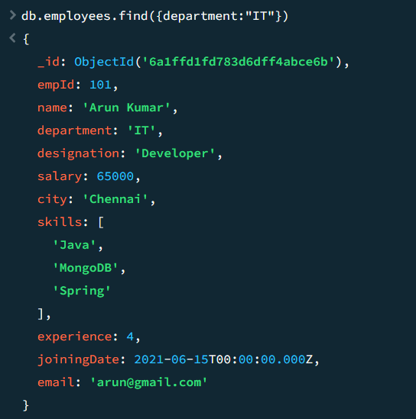
2. Multiple Conditions
Find employees whose salary is greater than 60,000 and experience is more than 3 years.
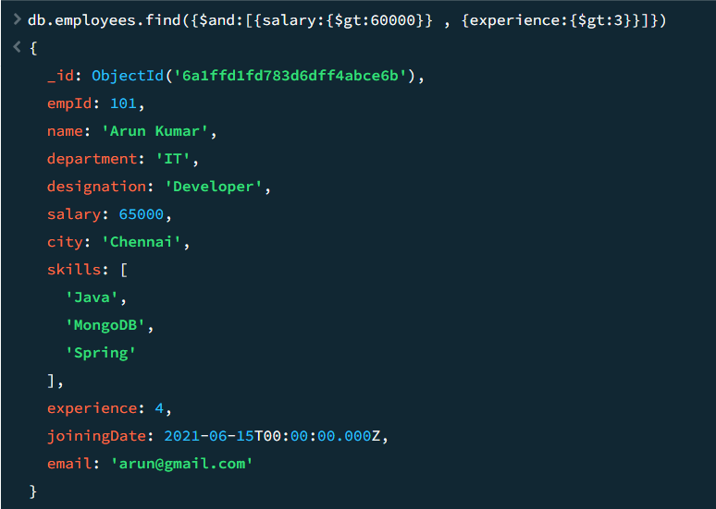

3. Projection
Display only:
- empId
- name
- salary
Hide _id.
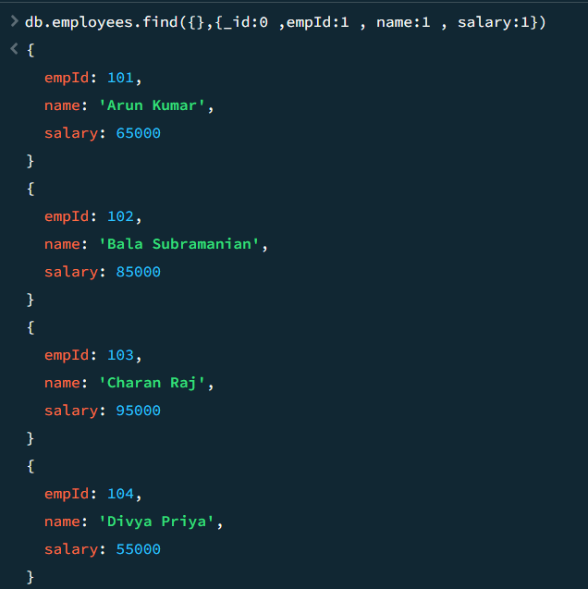

4. Range Query
Find employees whose salary is between 50,000 and 80,000.
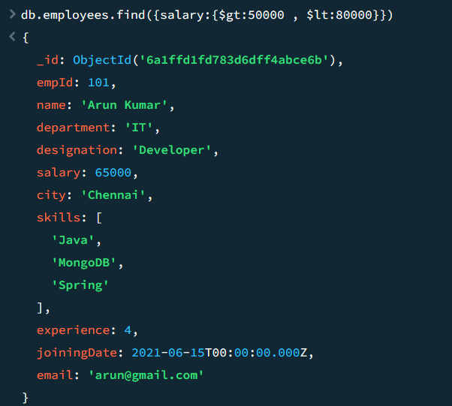

5. IN Condition
Find employees located in:
- Chennai
- Salem
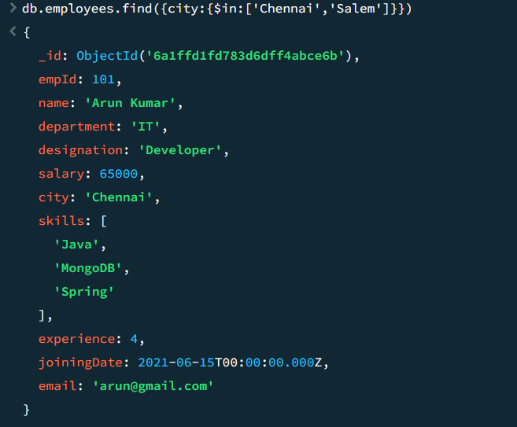

6. Array Search
Find employees who know MongoDB.
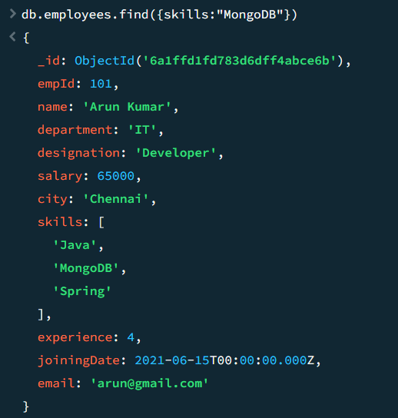

7. Multiple Array Elements
Find employees who know both:
- Java
- MongoDB
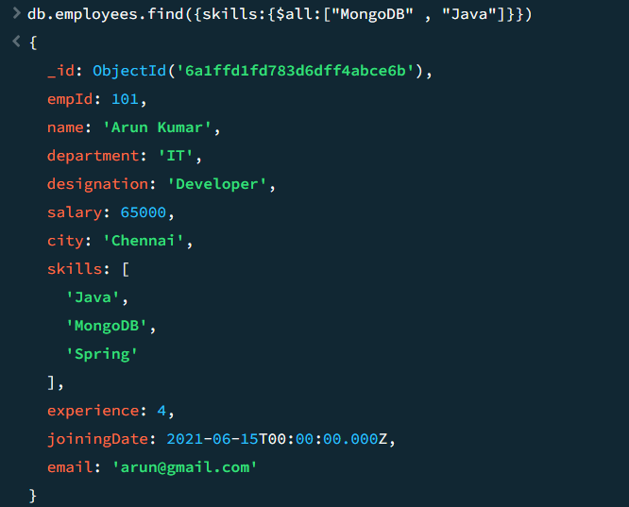
8. Exists Query
Find employees whose email field exists.
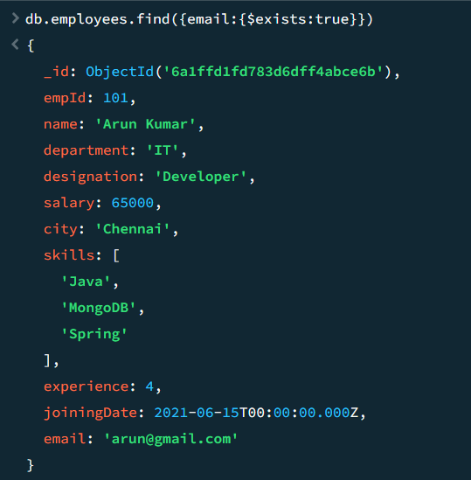

9. Type Query
Find documents where salary is stored as integer.
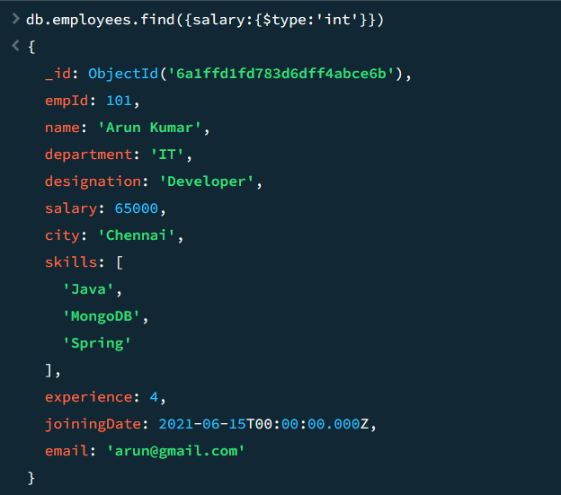

10. Sorting
Display employees sorted by salary ascending.
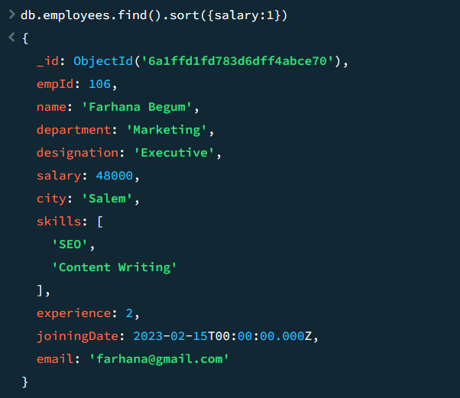
11. Descending Sort
Display employees sorted by experience descending.
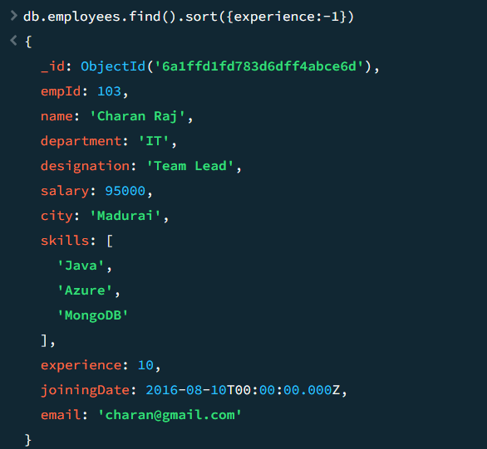
12. Multiple Field Sort
Sort employees by:
- Department ascending
- Salary descending
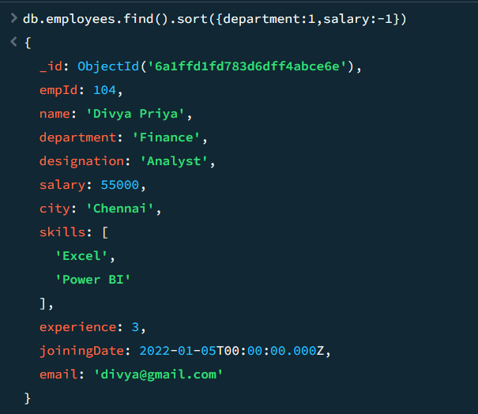
13. Limit
Display top 3 highest-paid employees.
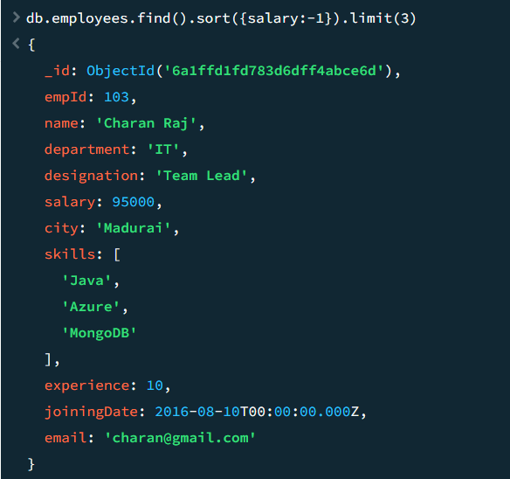

14. Skip
Skip first 2 employees and display remaining employees.
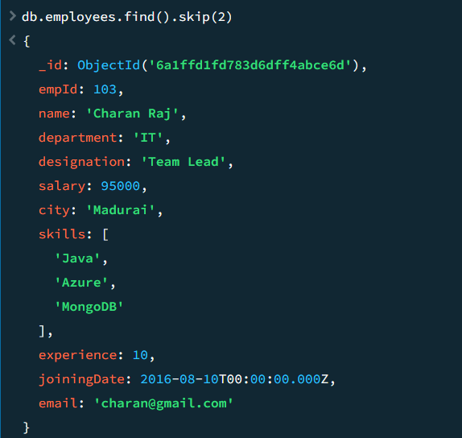

15. Pagination
Display page 2 with page size 2.
Expected:
skip(2).limit(2)
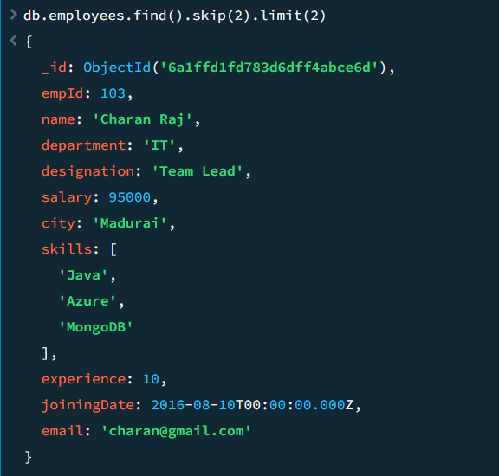
Here the skip and limit is based on page size which is usually 20 in most sites or apps so the skip should increment by 20 for each page

Text Search Tasks
Create text index first:
db.employees.createIndex({
name:"text",
designation:"text",
department:"text"
})

16. Text Search
Search for the word:
Developer
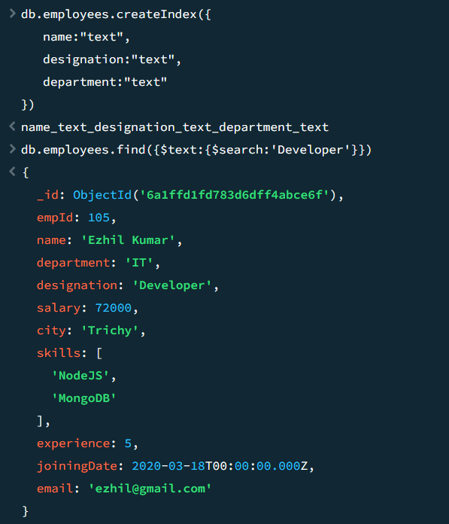

17. Search Multiple Words
Search:
IT Developer
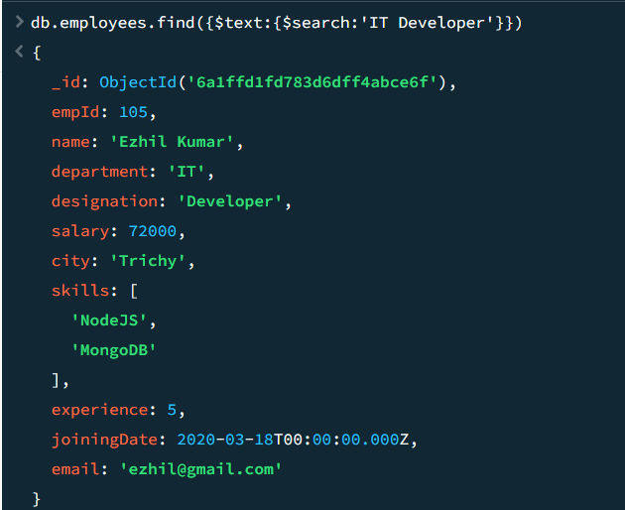
18. Phrase Search
Search exact phrase:
"Team Lead"
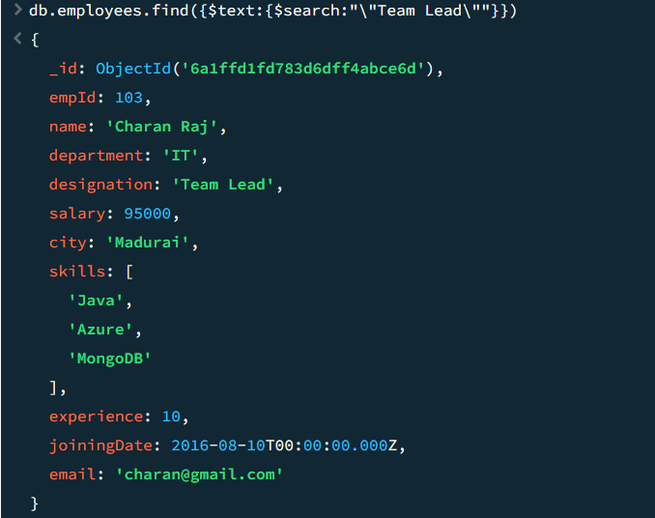

19. Text Score
Display relevance score along with results.
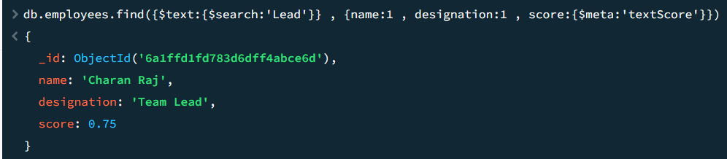
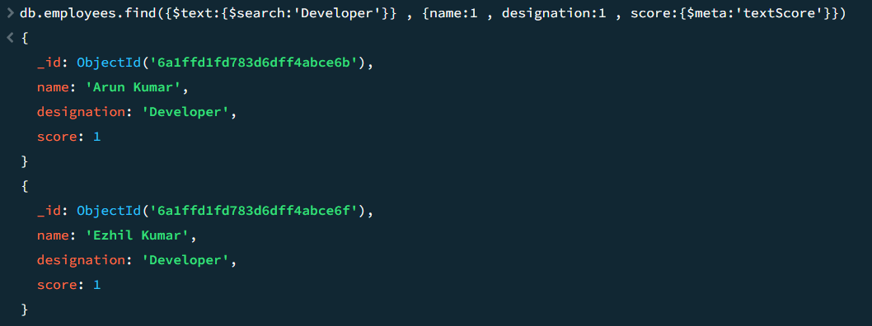

20. Sort by Text Score
Search MongoDB and sort results according to relevance score.
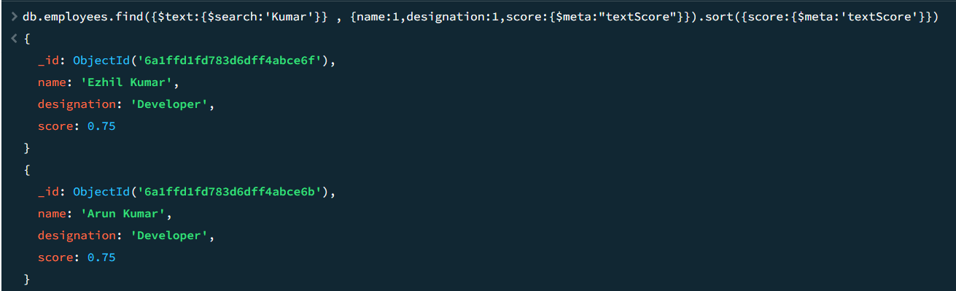
Regex-Based Tasks (Medium)
21. Names Starting with A
Find employees whose name starts with A.
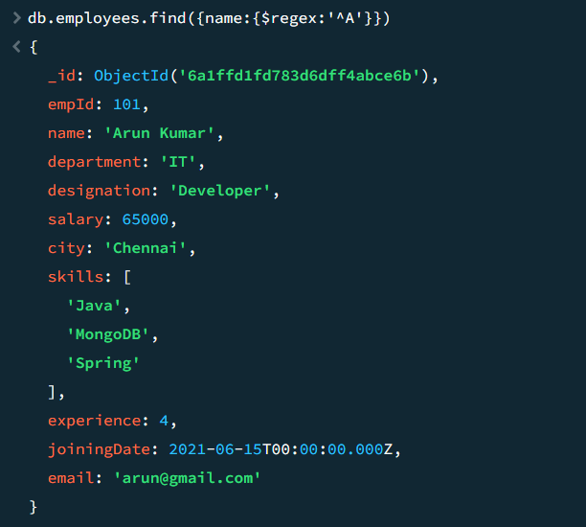

22. Names Ending with Kumar
Find employees whose name ends with Kumar.
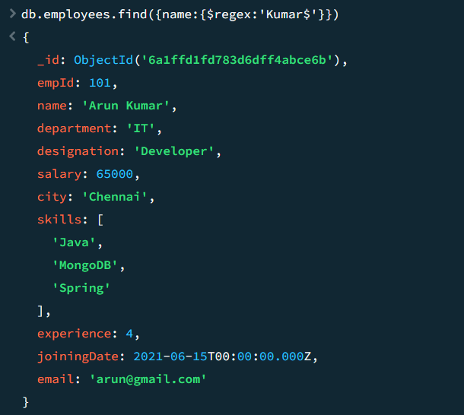

23. Contains "Raj"
Find employees whose name contains Raj.
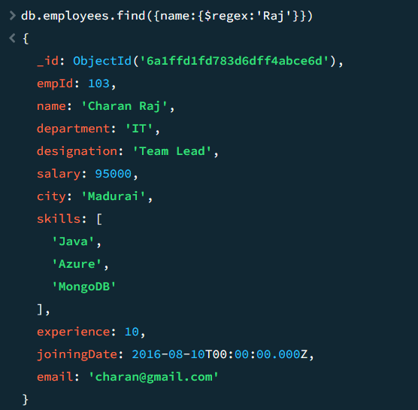
24. Case-Insensitive Search
Search for names containing:
kumar
regardless of case.
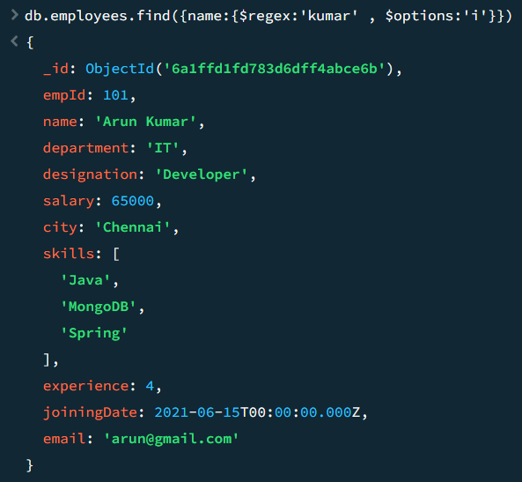
25. Gmail Users
Find employees whose email ends with: @gmail.com
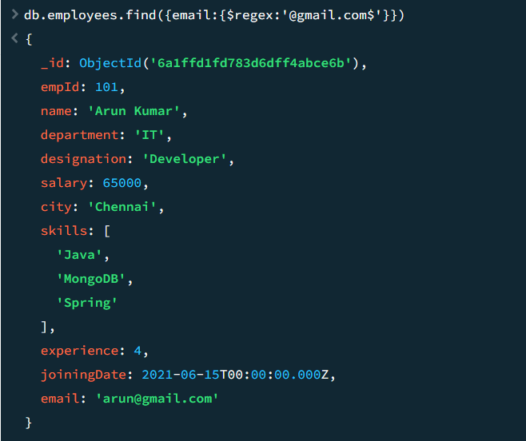
26. Designation Starts with D
Find designations beginning with D.
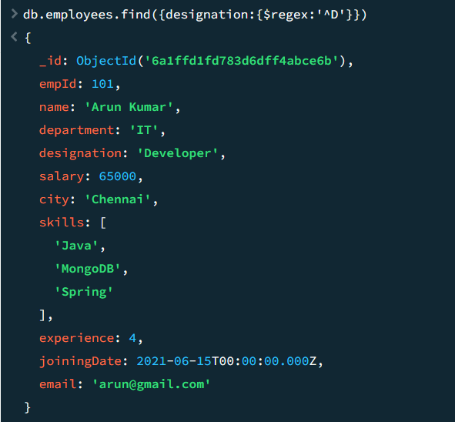

27. Cities Starting with C
Find employees from cities beginning with C.
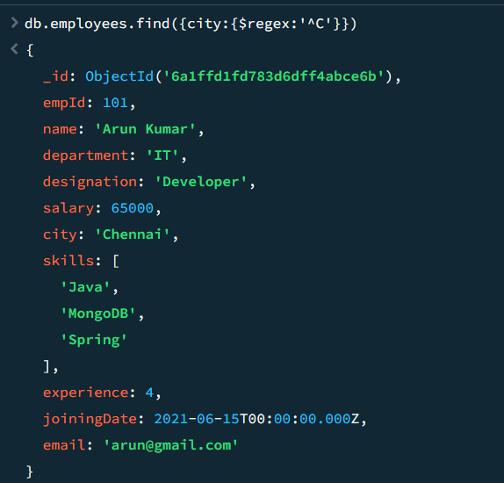

Advanced-Level Tasks
28. Complex AND + OR Query
Find employees who:
- belong to IT department
AND
- salary > 70,000
OR
- experience > 8 years
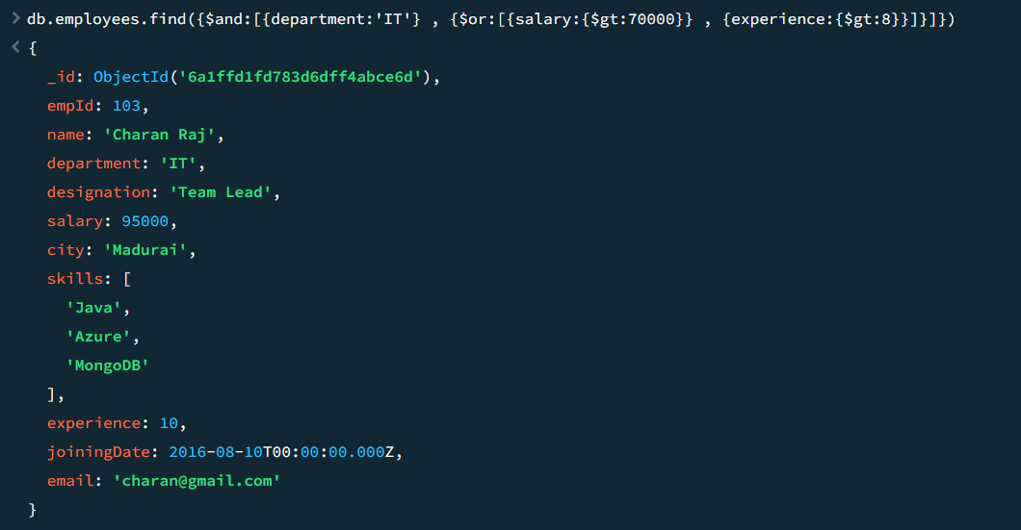

29. Regex + Salary Filter
Find employees whose:
- name contains Kumar
AND
- salary > 60,000
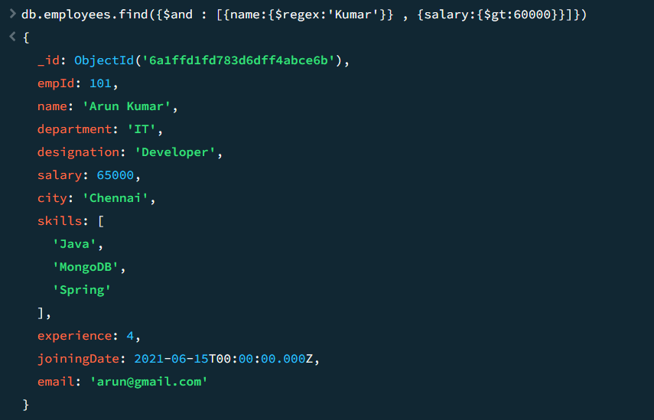
30. Pagination with Sorting
Display page 3.
Conditions:
- Sorted by salary descending
- Page size = 2
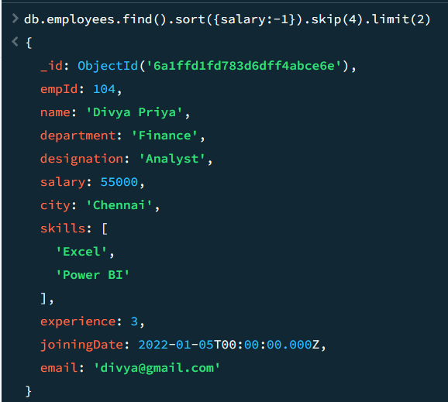
31. Top N Employees
Display top 5 highest-paid employees.
Show only:
- Name
- Salary
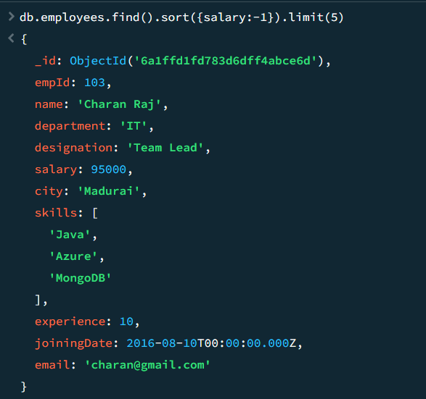
32. Second Highest Salary Employee
Without aggregation:
- Sort descending
- Skip first record
- Limit 1
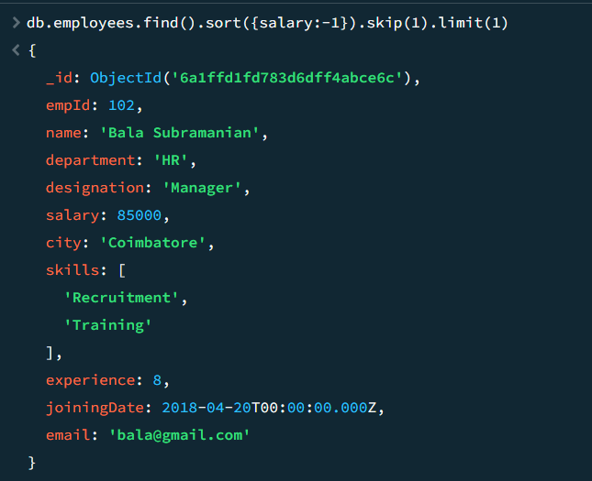
33. Recent Joiners
Display latest 3 joined employees.
Sort using joiningDate.
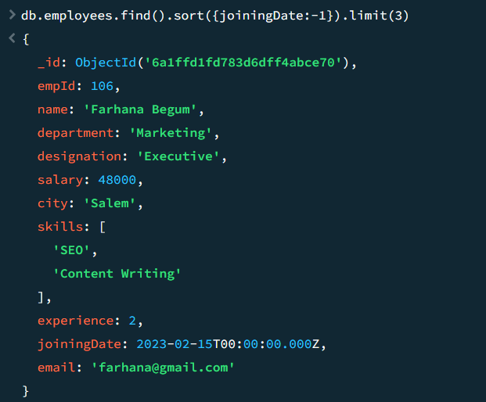

34. Regex with Multiple Patterns
Find employees whose name starts with:
- A
- B
- C
using single regex.
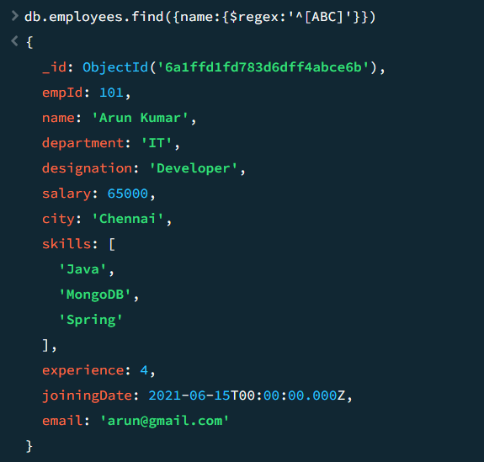
35. Advanced Email Validation
Find emails matching:
xxxxx@gmail.com
only.
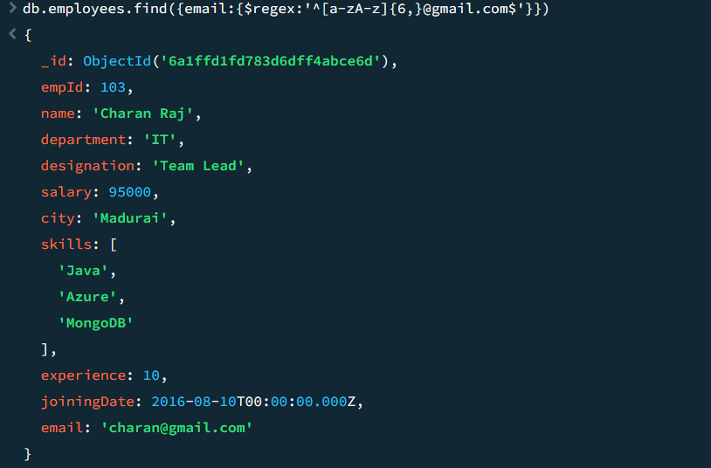
36. Regex + Array Search
Find employees who:
- know MongoDB
AND
- name starts with E
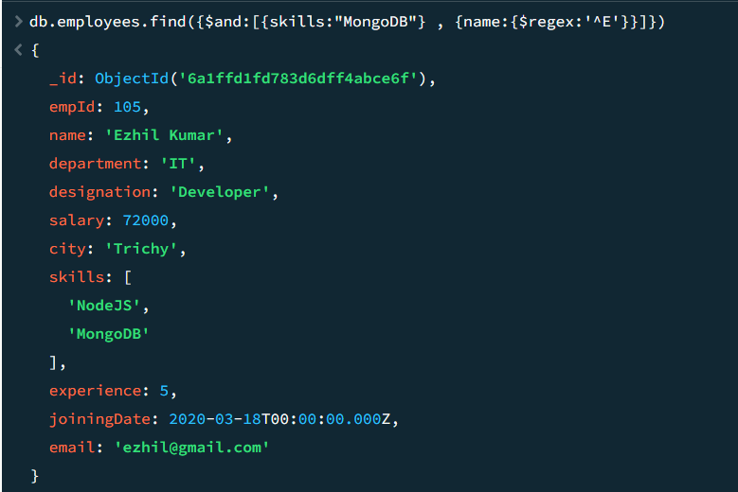
37. Department Wise Pagination
Display IT employees.
Requirements:
- Sort by salary descending
- Skip first employee
- Return next two employees
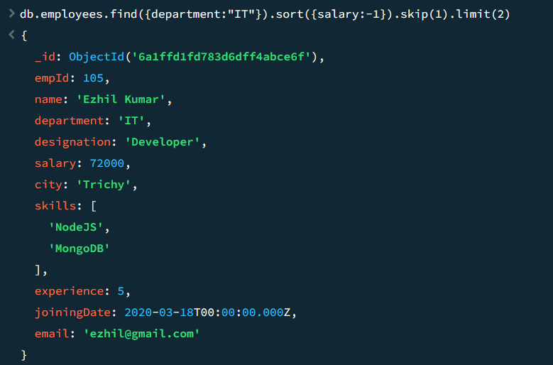
38. Case-Insensitive Department Search
Find department values matching:
it
regardless of case.
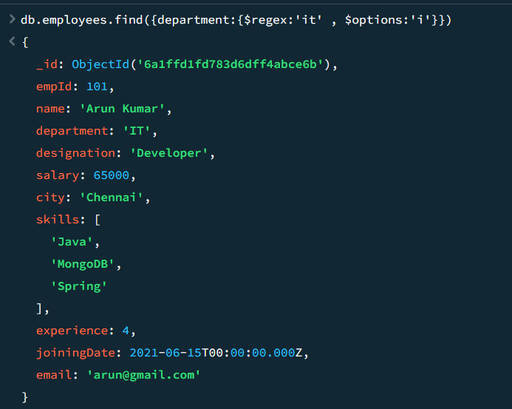

39. Search Employees Joined in 2021
Find employees whose joiningDate falls in 2021.
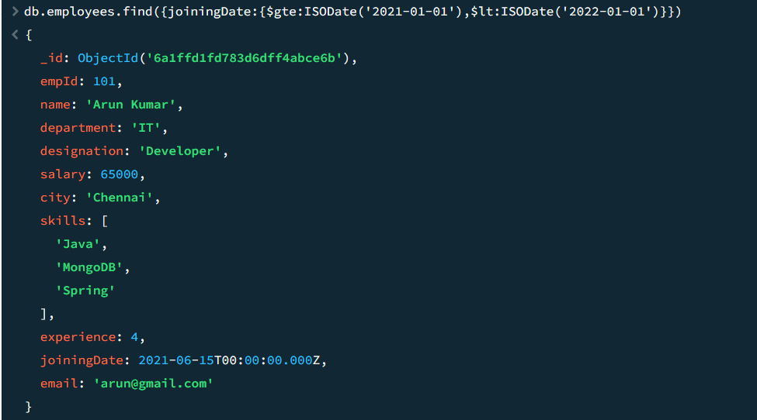

40. Combined Query
Find employees:
- Department = IT
- Skill = MongoDB
- Salary > 70,000
Sort by salary descending.
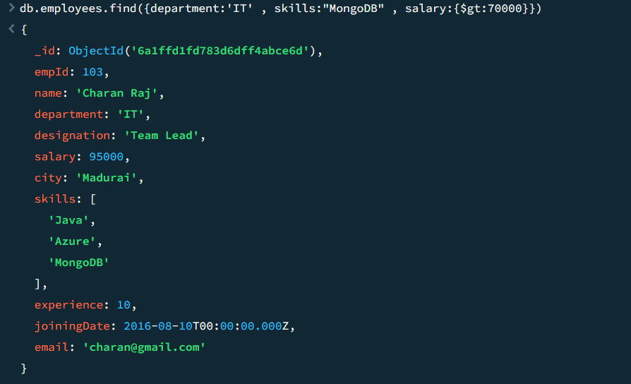

Advanced Challenge Tasks
41. Search and Rank
Perform text search for:
Developer MongoDB
Display:
- Name
- Designation
- Score
Sort by score.
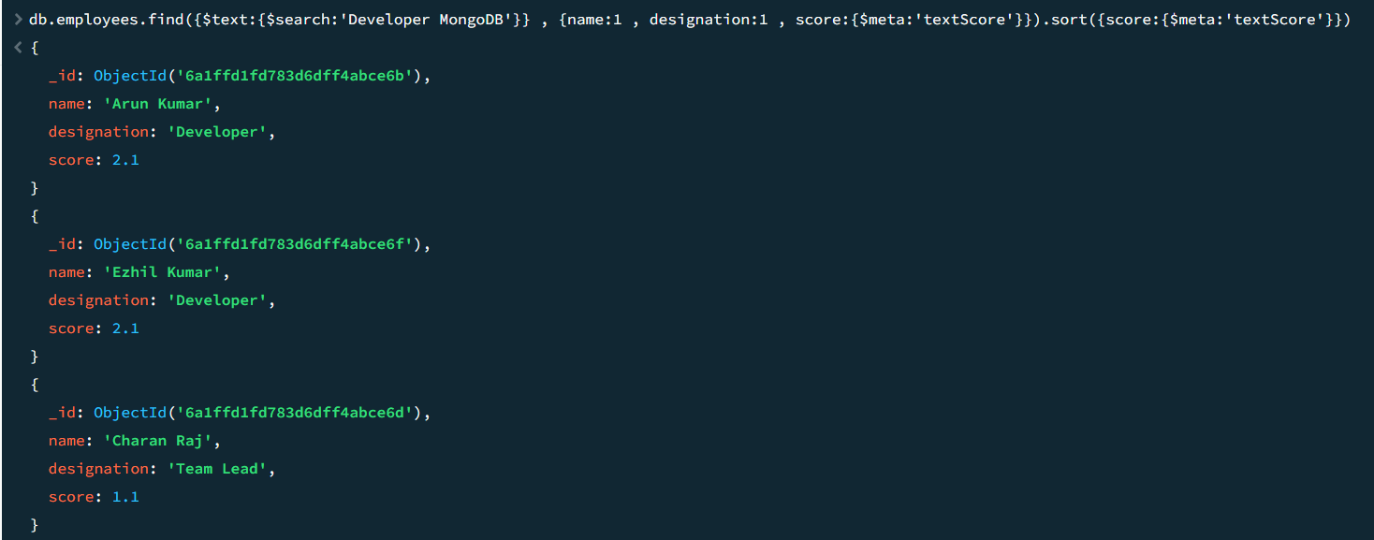
42. Infinite Scroll Query
Implement infinite scrolling.
Requirements:
- Sort by empId
- Fetch 3 documents at a time
- Simulate page 4
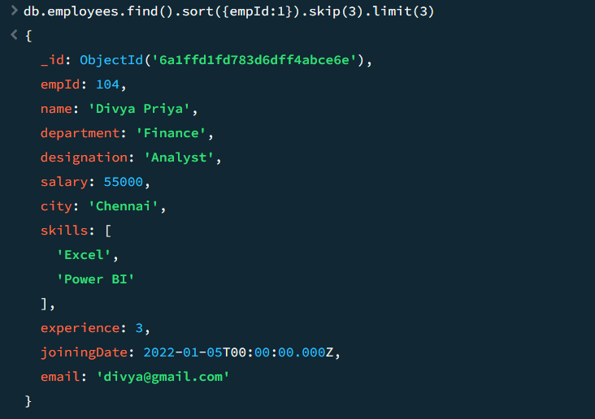
43. Complex Regex
Find employees whose name:
- Starts with a vowel
- Ends with "r"
Examples:
Arun Kumar
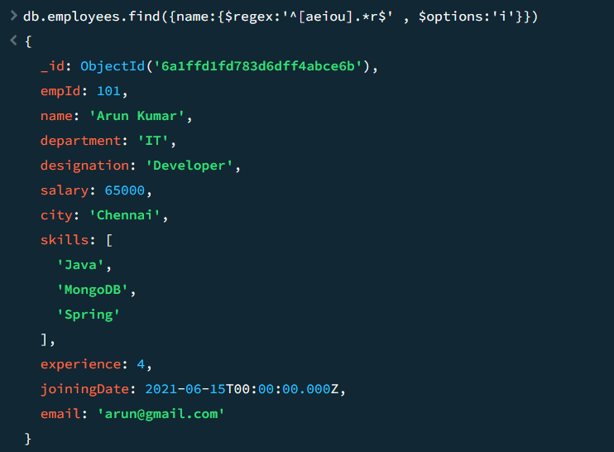

44. Multi-Field Search
Search keyword:
Manager
in:
- name
- designation
- department
using $or and regex.
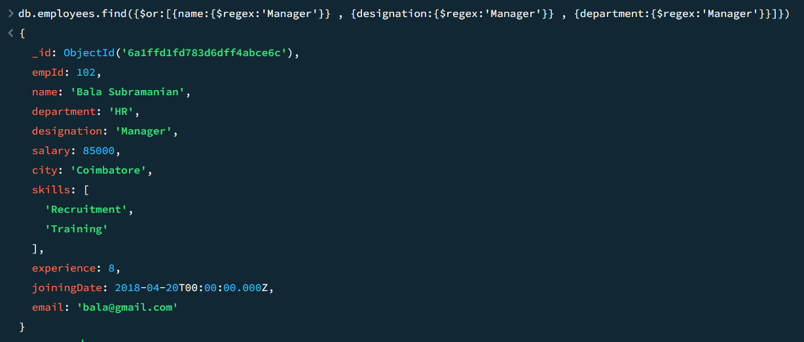
45. Search Dashboard Query
Build a query that supports:
- Search by keyword
- Department filter
- Salary range
- Sorting
- Pagination
This is a real-world employee management portal query.

46. Find Duplicate Cities
Using query and aggregation, identify cities having more than one employee.
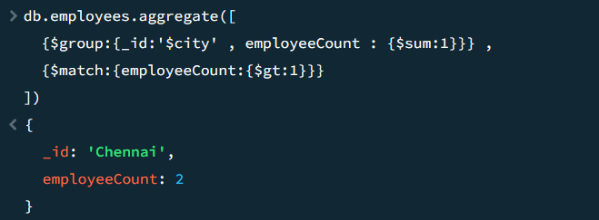
47. Recent IT Developers
Find employees:
- IT Department
- Designation contains Developer
- Joined after 01-Jan-2020
Sort by joiningDate descending.
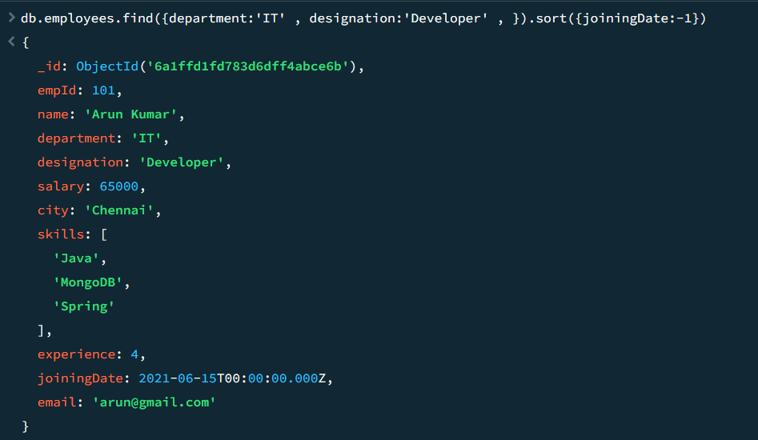

48. Keyword Search with Exclusion
Search employees matching:
Developer
but exclude:
Finance
department employees.
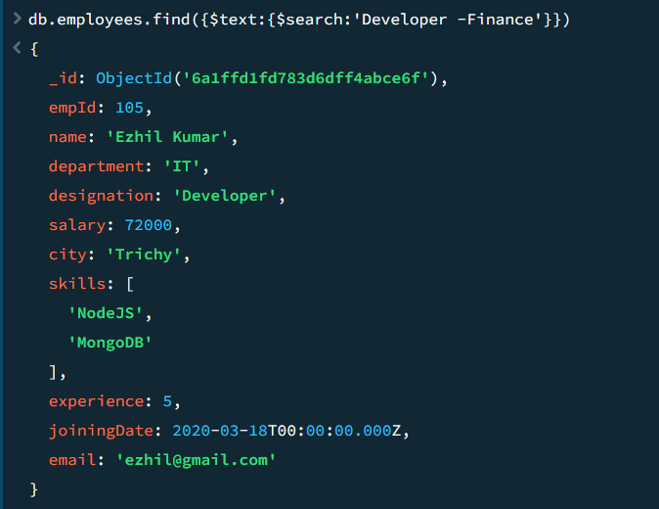

49. Dynamic Search API Task
Create a query that supports optional parameters:
department
city
minSalary
maxSalary
skill
pageNumber
pageSize
sortField
This mimics a production REST API filter.
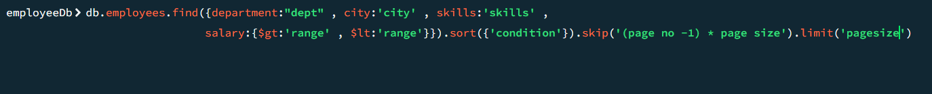
50. Master Challenge
Build a MongoDB query to generate:
- Employees knowing MongoDB
- Salary > 60,000
- Experience > 3 years
- Name contains Kumar
- Sorted by Salary Desc
  - Page Size = 2
  - Page Number = 2
using:
- find()
- regex
- sort()
- skip()
- limit()
in a single query.

